The SOLID Principles of Object-Oriented Programming

The SOLID Principles are five principles of Object-Oriented class design. They are a set of rules and best practices to follow while designing a class structure.

SOLID is a set of five object-oriented design principles that can help you write more maintainable, flexible, and scalable code based on well-designed, cleanly structured classes. These principles are a fundamental part of object-oriented design best practices.

Let's look at each principle one by one. Following the SOLID acronym, they are:
- The Single Responsibility Principle (SRP)
- The Open-Closed Principle
- The Liskov Substitution Principle
- The Interface Segregation Principle
- The Dependency Inversion Principle

1.The Single Responsibility Principle:

The Single Responsibility Principle states that a class should do one thing and therefore it should have only a single reason to change.
This means that a class should have only one responsibility, as expressed through its methods. If a class takes care of more than one task, then you should separate those tasks into separate classes.

Only one potential change (database logic, logging logic, and so on.) in the software’s specification should be able to affect the specification of the class.
This means that if a class is a data container, like a Book class or a Student class, and it has some fields regarding that entity, it should change only when we change the data model.

class Book {
/*
A simple POJO (Plain Old Java Object) class,
It contains private fields with corresponding getter and setter methods
*/
}

public class Invoice {

private Book book;

// And some other private fields with corresponding getter and setter methods

// it also include additional methods for behaviour.

public double calculateTotal() {
// Some business logic: calculates the total price
return priceWithTaxes;
}

public void printInvoice() {
// Some Printing Logic: to print in a particular formate
}

public void saveToFile(String filename) {
// Some Persistence Logic: Creates a file with given name and writes the invoice
}

}

Our class violates the Single Responsibility Principle (SRP) in multiple ways.
The first violation is the printInvoice method, which contains our printing logic. The SRP states that our class should only have a single reason to change, and that reason should be a change in the invoice calculation for our class.

But in this architecture, if we wanted to change the printing format, we would need to change the class. This is why we should not have printing logic mixed with business logic in the same class.

There is another method that violates the SRP in our class: the saveToFile method. It is also an extremely common mistake to mix persistence logic with business logic.

Don't just think in terms of writing to a file – it could be saving to a database, making an API call, or other stuff related to persistence.

So how can we fix this print function, you may ask.

We can create new classes for our printing and persistence logic (InvoicePrinter and InvoicePersistence) so we will no longer need to modify the invoice class for those purposes.

public class InvoicePrinter {
private Invoice invoice;

public InvoicePrinter(Invoice invoice) {
this.invoice = invoice;
}

public void print() {
// Some Printing Logic: to print in a particular formate
}
}

public class InvoicePersistence {
Invoice invoice;

public InvoicePersistence(Invoice invoice) {
this.invoice = invoice;
}

public void saveToFile(String filename) {
// Persistence logic: Creates a file with given name and writes the invoice
}
}

Now our class structure obeys the Single Responsibility Principle and every class is responsible for one aspect of our application. Great!

2. Open-Closed Principle:
The Open-Closed Principle requires that classes should be open for extension and closed to modification.

Modification means changing the code of an existing class, and extension means adding new functionality.

So what this principle wants to say is: We should be able to add new functionality without touching the existing code for the class. This is because whenever we modify the existing code, we are taking the risk of creating potential bugs. So we should avoid touching the tested and reliable (mostly) production code if possible.

But how are we going to add new functionality without touching the class, you may ask. It is usually done with the help of interfaces and abstract classes.

Let's say our boss came to us and said that they want invoices to be saved to a database so that we can search them easily. We think okay, this is easy peasy boss, just give me a second!
We create the database, connect to it, and we add a save method to our InvoicePersistence class:

public class InvoicePersistence {
Invoice invoice;

public InvoicePersistence(Invoice invoice) {
this.invoice = invoice;
}

public void saveToFile(String filename) {
// Persistence logic: Creates a file with given name and writes the invoice
}
public void saveToDatabase() {
// Persistence logic: Saves the invoice to database
}
}

Unfortunately we, as the lazy developer, did not design the classes to be easily extendable in the future. So in order to add this feature, we have modified the InvoicePersistence class.
If our class design obeyed the Open-Closed principle we would not need to change this class.

So, as the lazy but clever developer, we see the design problem and decide to refactor the code to obey the principle.

interface InvoicePersistence {

public save(Invoice invoice) ;
}
public class FilePersistence implements InvoicePersistence {

@Override
public save(Invoice invoice) {
// Persistence logic: Creates a file with given name and writes the invoice
}
}
public class DatabasePersistence implements InvoicePersistence {

@Override
public save(Invoice invoice) {
// Persistence logic: Saves the invoice to database
}
}

So our class structure now looks like this:
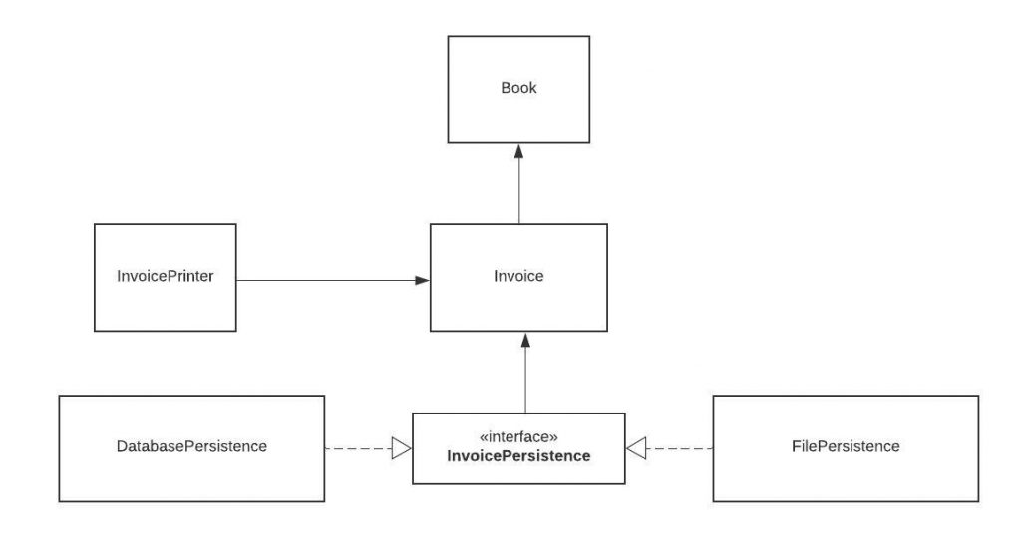

Now our persistence logic is easily extendable. If our boss asks us to add another database and have 2 different types of databases like MySQL and MongoDB, we can easily do that.
You may think that we could just create multiple classes without an interface and add a save method to all of them.

3. Liskov Substitution Principle

The Liskov Substitution Principle states that subclasses should be substitutable for their base classes.
This means that, given that class B is a subclass of class A, we should be able to pass an object of class B to any method that expects an object of class A and the method should not give any weird output in that case.
This is the expected behavior, because when we use inheritance we assume that the child class inherits everything that the superclass has. The child class extends the behavior but never narrows it down.
Therefore, when a class does not obey this principle, it leads to some nasty bugs that are hard to detect.

4. Interface Segregation Principle

Segregation means keeping things separated, and the Interface Segregation Principle is about separating the interfaces.
The principle states that many client-specific interfaces are better than one general-purpose interface. Clients should not be forced to implement a function they do no need.

5. Dependency Inversion Principle
The Dependency Inversion principle states that our classes should depend upon interfaces or abstract classes instead of concrete classes and functions.

